Birla Institute of Technology & Science, Pilani
Work-Integrated Learning Programmes Division
II Semester 2014-2015
Compre exam (EC-3, Regular) – Key

Course No. : SS ZG527
Course Title : CLOUD COMPUTING
1.

- Lower computer costs
Yes. A high-powered computer is not needed to run cloud-based applications. Since applications run in the cloud, a desktop computer does not need the processing power or hard disk space demanded by traditional desktop software
- Improved performance
Yes. Desktop computers that use cloud-based services may boot and run faster because they have fewer programs and processes loaded into memory
- Reduced software costs
Yes. Instead of purchasing software applications, cloud computing applications can often be obtained for free (ex. google docs)
- Instant software updates
Yes. Updates to a cloud-based application generally occur automatically and are available (latest version) instantly on logging into the cloud.
- Unlimited storage capacity
Yes. Cloud computing can offer virtually limitless storage
- Increased data reliability
Yes. Unlike desktops, in which a hard disk crash can destroy personal data, a VM crashing in the cloud should not affect the storage of data, as typically cloud services provide data redundancy facility
- Universal document access
Yes. Documents stored in the cloud can be accessed from anywhere with an Internet-capable device and an Internet connection
- Device independence
Yes. Cloud computing is ubiquitous.
2.

Managed Service Provider Cloud platform SLA: (3+3marks)
- Possible SLA's are identified for the application -> SLA acceptable to customer? -> Estimate cost for each SLA -> Cost is acceptable to customer? -> Chose different SLAs OR Create policies for each SLA.
- SLA violation -> Is it repeated SLA violation? OR Customer request for new/modification of SLA -> Rollback the app from production environment
3.

- Database design
  - Dedicated tables approach

CSE
Emp_Id | FName | ReseachArea
101 | Prof. Dinesh | Cloud computing
102 | Prof. Rajan | Network security
EEE
Emp_Id | FName | ReseachArea
201 | Prof. Ray | Power Engineering
202 | Prof. Thomas | Power Systems
ECE
Emp_Id | FName | ReseachArea
301 | Prof. Raman | Semi-conductors
302 | Prof. Sujana | Embedded systems

  - Shared tables approach
Data table1:
Did | Emp_Id | FName | ReseachArea
CSE | 101 | Prof. Dinesh | Cloud computing
EEE | 201 | Prof. Ray | Power Engineering
ECE | 301 | Prof. Raman | Semi-conductors
EEE | 202 | Prof. Thomas | Power Systems
CSE | 102 | Prof. Rajan | Network security
EEE | 203 | … | …..
Meta data table1:
Did | Dname
CSE | Computer Science
EEE | Electrical Engineering
ECE | Electronics and communication

Customization approaches:
In Dedicated table method, each tenant has its own table, and therefore can have different schema. Difficulty is with shared table approach
Three method used
  - Pre-allocated columns
  - Name-value pair
  - XML method
Feasible approach: Name-value pair

Data table1:
Did | Emp_Id | FName | ReseachArea | Name_val_pair
CSE | 101 | Prof. Dinesh | Cloud computing | 100
EEE | 201 | Prof. Ray | Power Engineering | 200
ECE | 301 | Prof. Raman | Semi-conductors
EEE | 202 | Prof. Thomas | Power Systems
CSE | 102 | Prof. Rajan | Network security
EEE | 203 | … | …..
Data table2:
Name_val_pair | Name_id | value
100 | 20 | Information Security
200 | 30 | 15
Metadata table1:
Name_id | Name | Type
20 | Research topic | string
30 | No of faculty | int
Metadata table1:
Did | Dname
CSE | Computer Science
EEE | Electrical Engineering
ECE | Electronics and communication

4.
a. Risks related to Cloud computing:
The biggest perceived barriers for both consumer and SME take-up of cloud computing are lack of privacy, data standardization, and jurisdictional issues relating to applicable law and law enforcement access to data.
b.Cloud computing in the future:
- In the short term, it is uncertain whether there will be significant changes in the types of cloud services offered. However, their availability and capacity are likely to continue to increase, as economies of scale drive ever-larger data centers, which will continue to migrate towards sites with cheaper energy.
- While some services are likely to move to the public cloud given the potential cost savings, other services will still remain in a private environment
- Issues such as security and privacy could slow down development because if business users or public authorities do not have the confidence or the evidence that public clouds can be trusted, they are unlikely to take up the cloud model

- Self-explanatory question. May have different answers based on students understanding level.

6.
a. Data distribution
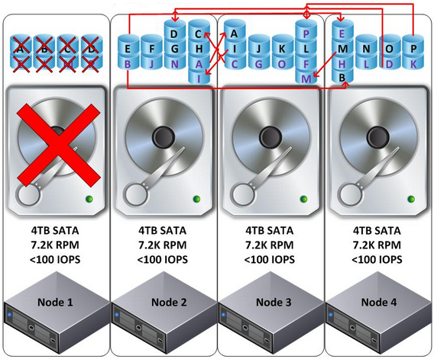
b.
Node 2 |  | Node 3 |  | Node 4
Read I/O | Write I/O | Read I/O | Write I/O | Read I/O | Write I/O
3 | 3 | 2 | 3 | 3 | 2

7.

- Nova: It provides virtual servers upon demand. It allows users to create, destroy, and manage virtual machines using user-supplied images.
- Glance: It provides a catalog and repository for virtual disk images (Imaging Service)
- Keystone: It provides authentication and authorization for all the OpenStack services. It also provides a service catalog of services within a particular OpenStack cloud
- Neutron: It provides "network connectivity as a service" between interface devices managed by other OpenStack services

